Weekly District Report
Kathmandu Valley
26 Oct to 2 Nov 2017

Activity Summary
Activity | Contact Person | Reference Document
Meeting coordination meeting at NRA Lalitpur | Sweata Sijapati  techcord.ktm@hrrpnepal.org
Update of the 4W | im.national@hrrpnepal.org
Technical meeting with NRA, DLPIU chief and DLPIU engineers | Sweata Sijapati  techcord.ktm@hrrpnepal.org
Field visit to Machhegaun, Chandaragiri Municipality | Sweata Sijapati  techcord.ktm@hrrpnepal.org

Upcoming Events & Meetings
Event / Meeting | Date, Time, and Location | Contact Person
Monthly coordination meeting at NRA ( Kathmandu) | NRA office, Kathmandu on 3 November 2017 | Sweata Sijapati
Collection of hollow block sample | 13- 15 November 2017 | Sweata Sijapati
To include details of upcoming events and meetings in the next bulletin, please share details with techcord.ktm@hrrpnepal.org by COB Wednesday of each week.

News & Updates
- The resurvey and reverification of the grievances is ongoing in Kathmandu, Bhaktapur and Lalitpur district. As per date 1821 grievances has been listed in the beneficiary list whereas 3194 has been forwarded for the resurvey in Lalitpur district.
- NRA has planned for 3 masons training has been planned in each districts. The details of the training (Date and Location) will be shared in later date.

- Reconstruction update of Bhaktapur district

Field Visit Reports
Date |  | Location |  |  | Participants
27 October 2017 |  | Machhegaun, Chandragiri Municipality |  |  | - Local elected bodies, M&E consultant-Kathmandu, Lumanti (field staffs), DLPIU engineers of Chandragiri Municipality
Objective(s) | - Monitor the ongoing reconstruction supported by Lumanti Support group of shelter  - Discuss on the issues (technical and social) that has hindered the reconstruction process
Summary | A joint field visit of HRRP Kathmandu valley and monitoring and evaluation consultant-Kathmandu was conducted on October 27, 2017 to Machhegaun, ward no 9, Chandragiri Municipality, Kathmandu. Before conducting the field visit a brief meeting with the ward chief, ward member, Women’s’ cooperative group, DLPIU engineers, Monitoring and evaluation consultant – Kathmandu, HRRP and Lumanti staffs was conducted. The issues of the bylaws in the area (mostly the houses which couldn’t get the building permit) were discussed. Also, the way to motivate the beneficiaries to build an earthquake resistant houses were briefly discusses. The ward chief further added that all the issues that have been affecting the construction process will be added as an agenda for the meeting with the Municipality.  Lumanti has been supporting the reconstruction of 115 houses among them 40 houses are under construction. Due to small land size 13 houses under construction are load bearing structure with eccentric footing. Due to this the building are considered non-compliance. The way forward to solve the issue and address the non-compliance cases so that the beneficiaries will be eligible for the 2nd tranche.
Challenges / Issues Identified |  |  | Action Required |  | Responsible | Timeframe
Bylaws issue in the core areas |  |  | Municipality and local bodies must take action to address the issues.
Load bearing structure with eccentric footing |  |  | Structural analysis needed |  | Engineers from Lumanti with support of District support engineers and CLPIU
Photos
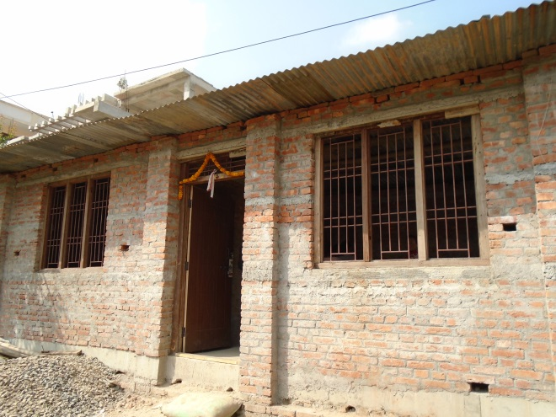 |  |  |  | 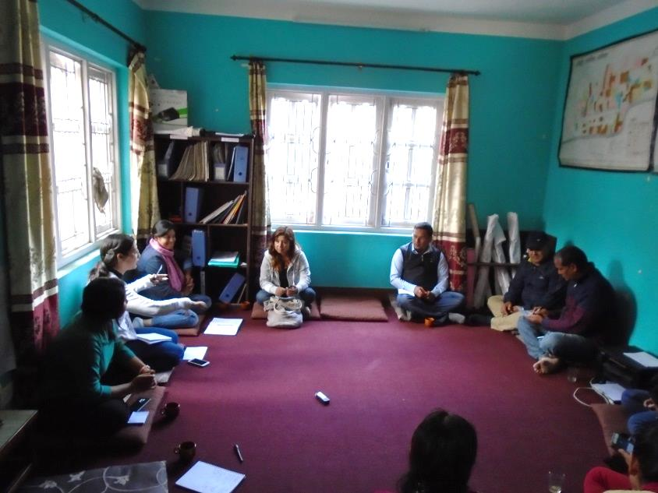
Machhegau Ward no 9, Changdragiri Municipality, 1 storey Load bearing structure. Beneficiary has received 1st tranche. |  |  |  | Lumanti Chandragiri office, Meeting with the local elected bodied, M&E consultant and Lumanti staffs to address the issues and challenges in the reconstruction process
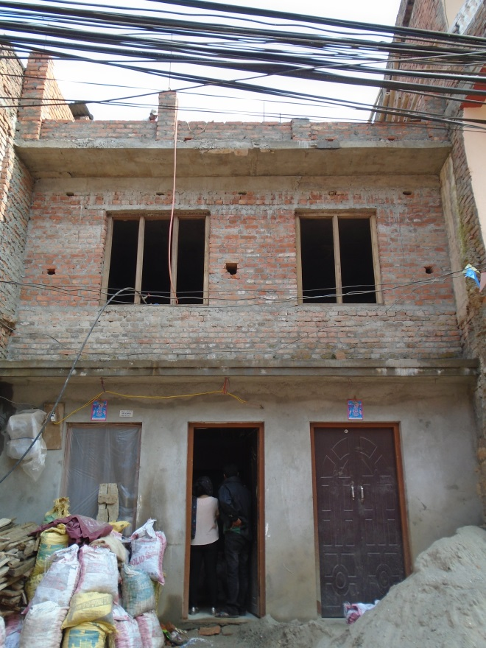 |  |  |  | 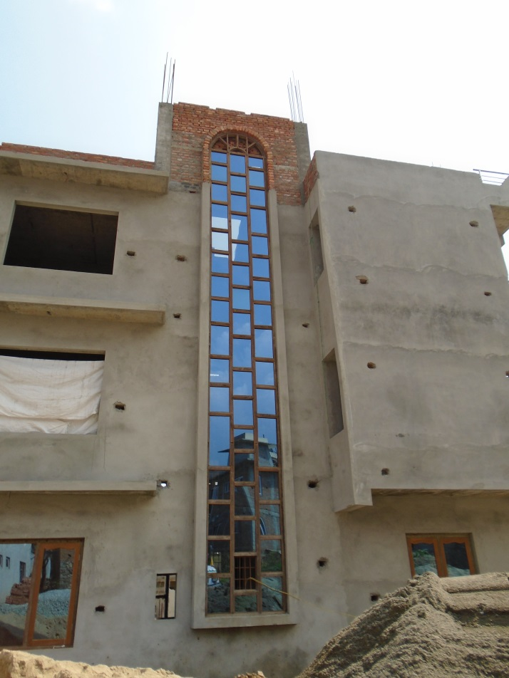
Machhegau Ward no 9, Changdragiri Municipality, 2 storey Load bearing structure with eccentric footing. Beneficiary has received 1st tranche. |  |  |  | Machhegau Ward no 9, Changdragiri Municipality, 3 storey RCC structure. Beneficiary has received 1st tranche and requested for the remaining tranche.

Housing Typology Report
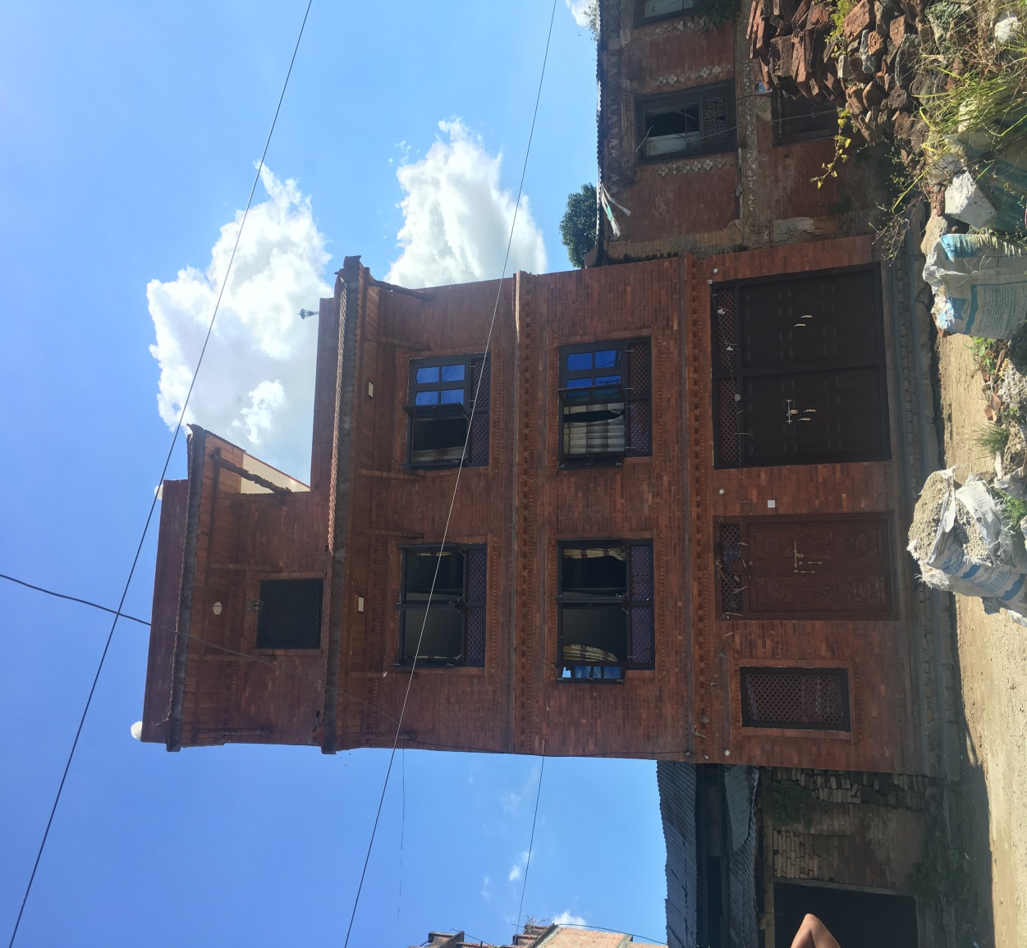 | 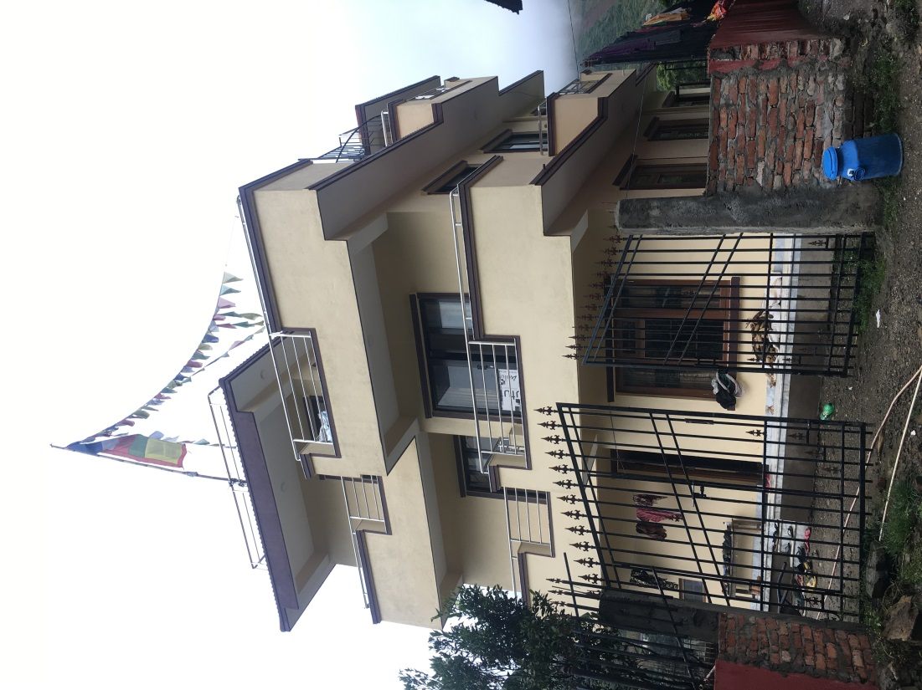
Shankharapur Municipality, Ward no 7, 3.5 storey RCC structure with traditional architect. Beneficiary has received 1st tranche and have requested for the 2nd tranche. | Konjyosom Rural Municipality, Bhardev Ward no 5, 2.5 storey RCC structure. Beneficiary has received 1st tranche and have requested for the 2nd tranche.

Questions Collected
Question | Who Asked the Question? | Response Provided (By Whom)

Challenges and Way Forward
Challenge | Way Forward
The non-compliance cases has not been forwarded by Bhaktapur Municipality | NRA Chief and DLPIU Bhaktapur have been on talk with the municipality regarding this issue.
The building permit has been stopped in Chandragiri Municipality due to which beneficiaries haven’t been able to request for the 2nd tranche. | Several meeting has been conducted to address the issue but no firm decision has been made.

